**Module 8) Bootstrap Basic & Advanced**

**1.What are the advantages of Bootstrap?**

**Ans:-**

* Bootstrap is a css framework.
* It’s very easy to learn.
* It contains lots of styling which one can apply css properties by adding appropriate class.
* We can also create responsive design with bootstrap very easily

**2. What is a Bootstrap Container, and how does it work?**

**Ans:-**

* Containers are used give some padding to all sides.

Ex:-

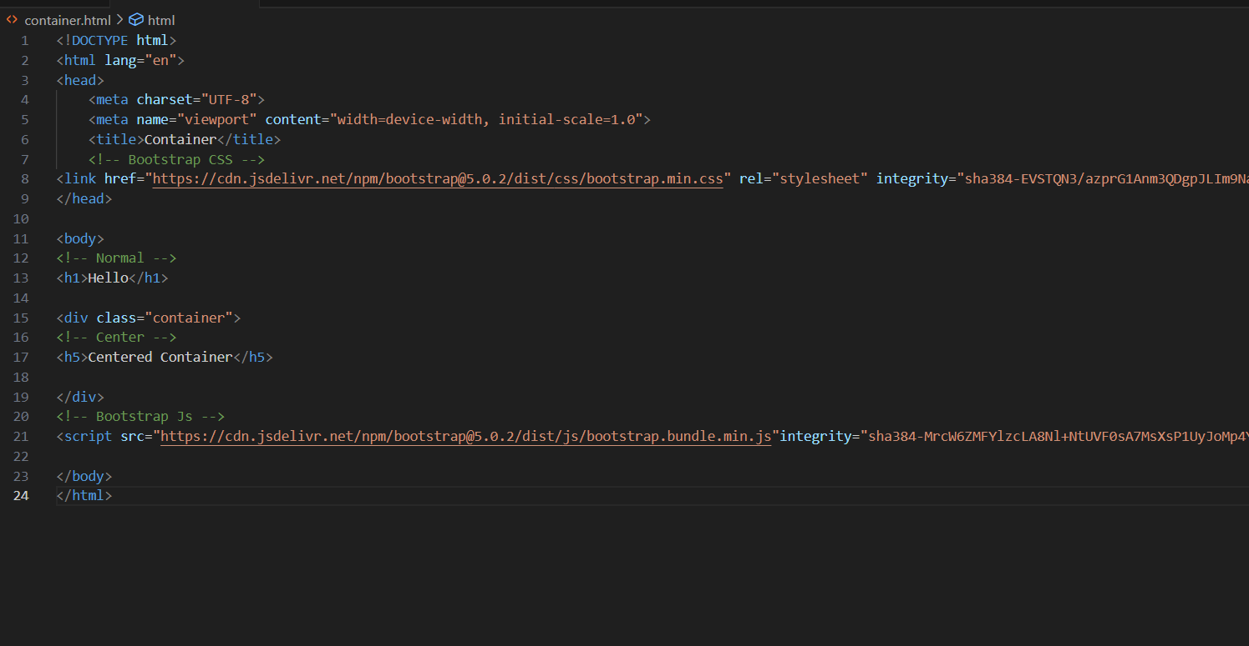

Output:-

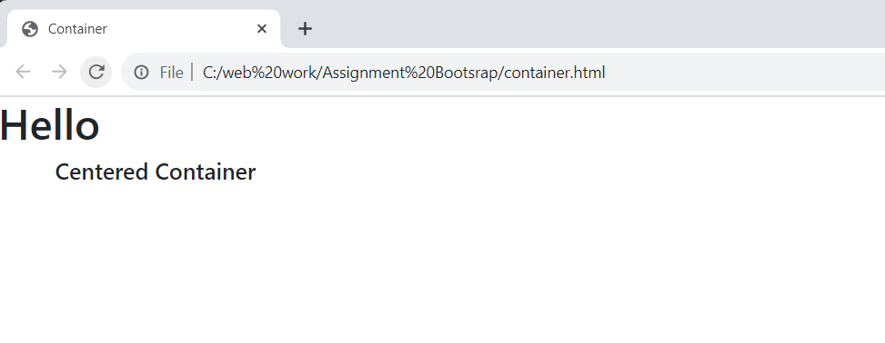

**3.What are the default Bootstrap text settings?**

**Ans:-**

* Bootstrap 4 uses a **default font-size of 16px, and its line-height is 1.5**.
* The default font-family is "Helvetica Neue", Helvetica, Arial, sans-serif.

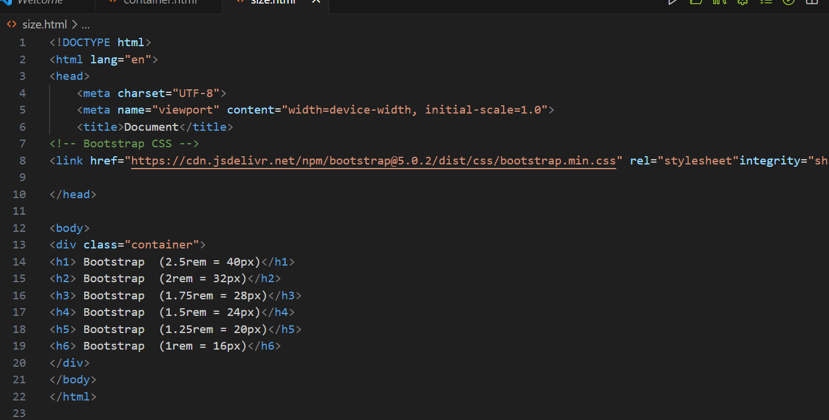

Output:-

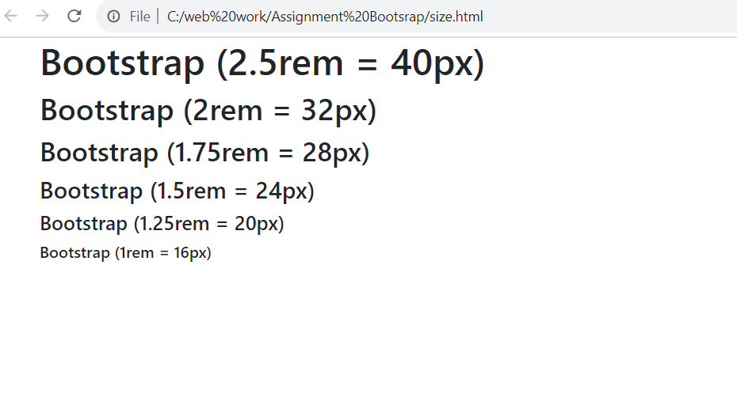

**4. What do you know about the Bootstrap Grid System?**

**Ans:-**

* By using bootstrap’s grid system we can make responsive content.
* Bootstrap's grid system uses a series of containers, rows, and columns to layout and align content.

Ex:-

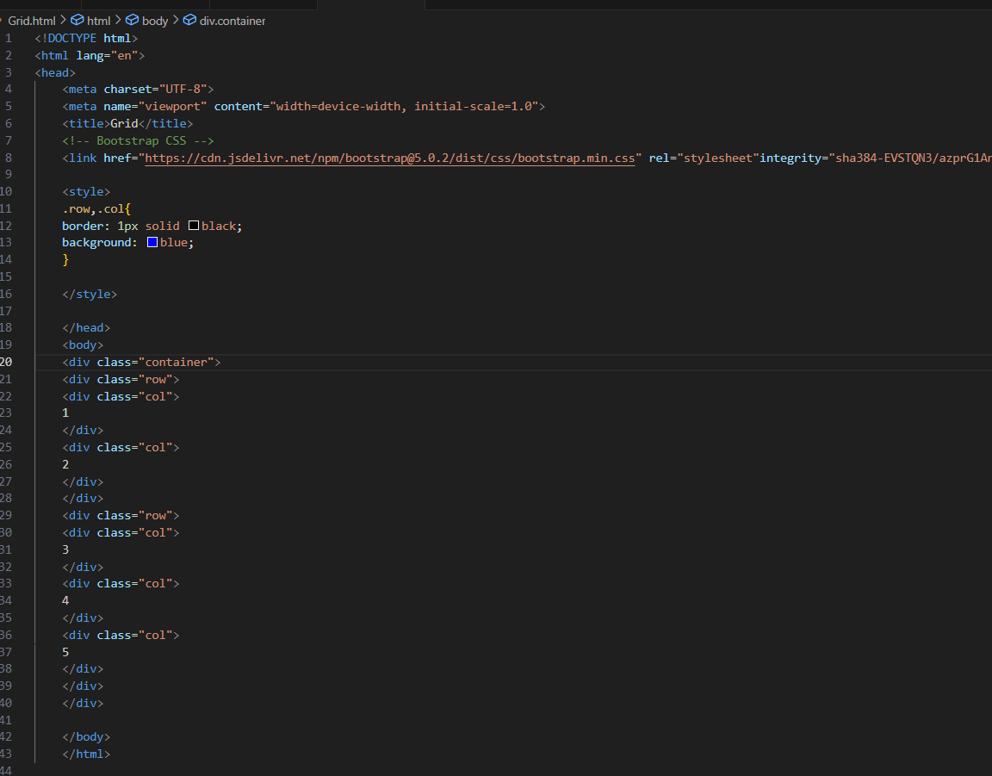

Output:-

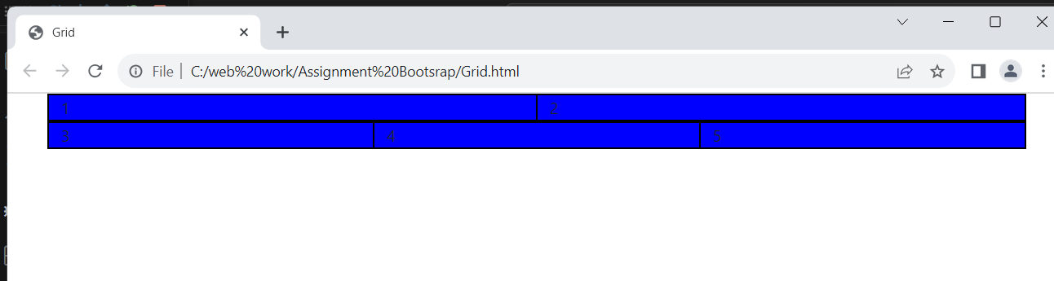

**5. What is the difference between Bootstrap 4 and Bootstrap 5**

**Ans:-**

The form elements in Bootstrap 4 have defaulted to the browser-provided view. However, in Bootstrap 5, the form elements have a custom design that enables them to have a consistent look and feel in all browsers.

**6. What is a Button Group, and what is the class for a basic Button Group?**

**Ans:-**

“Button Groups” in Bootstrap is a class of name “btn-group” which is used to create a series of buttons in groups (without spaces) vertically or horizontally. Syntax: This is the basic syntax of the button group class where each button has its own class of “btn”.

**Ex:-**

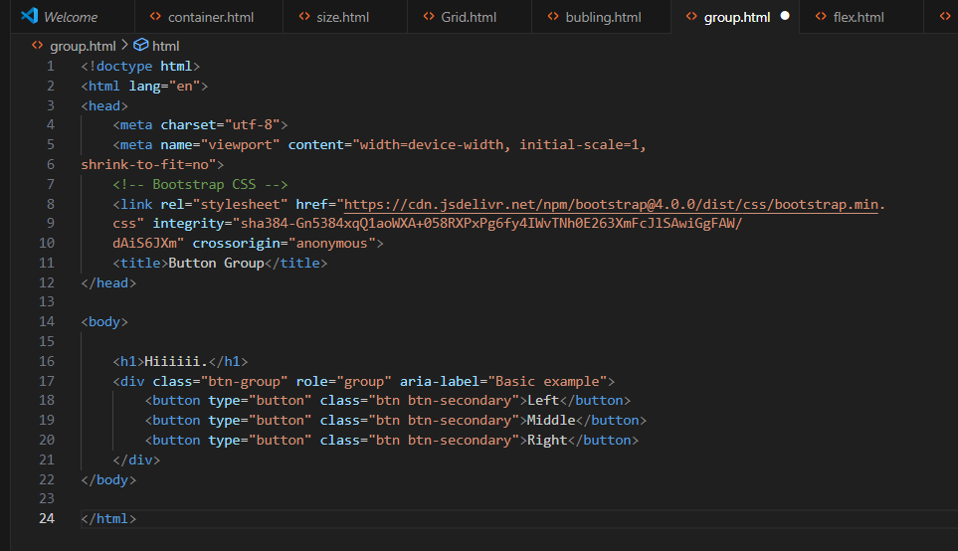

Output:-

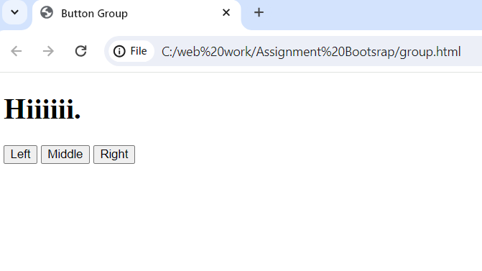

**7. In Bootstrap 4, what is flexbox?**

**Ans:-**

Quickly manage the layout, alignment, and sizing of grid columns, navigation, components, and more with a full suite of responsive flexbox utilities.

**Ex:-**

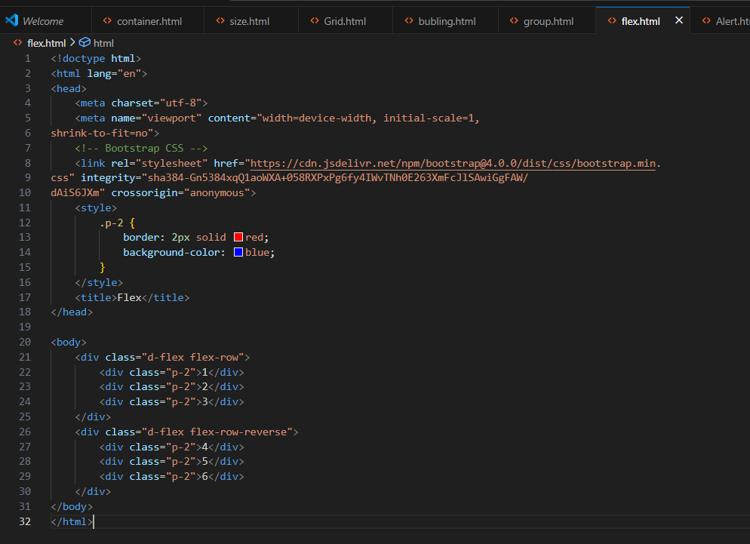

**Output:-**

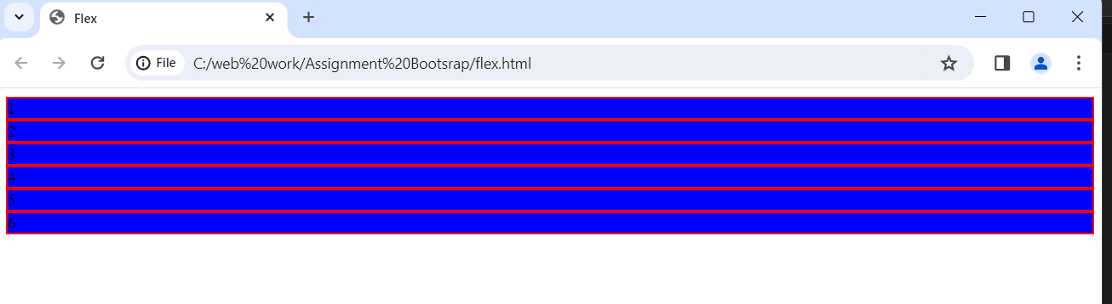

**8. How can one create an alert in Bootstrap?**

**Ans:-**

Alerts are available for any length of text, as well as an optional dismiss button.

**Ex:-**

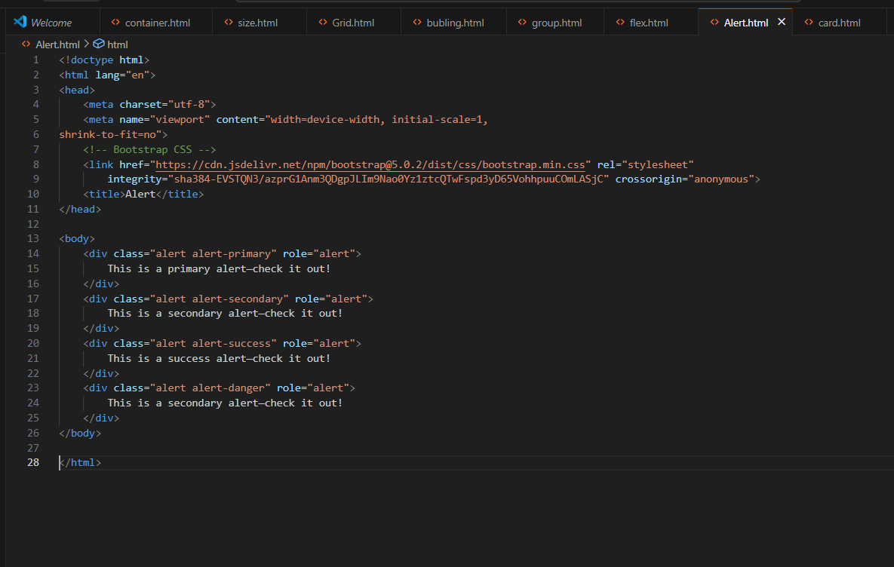

**Output:-**

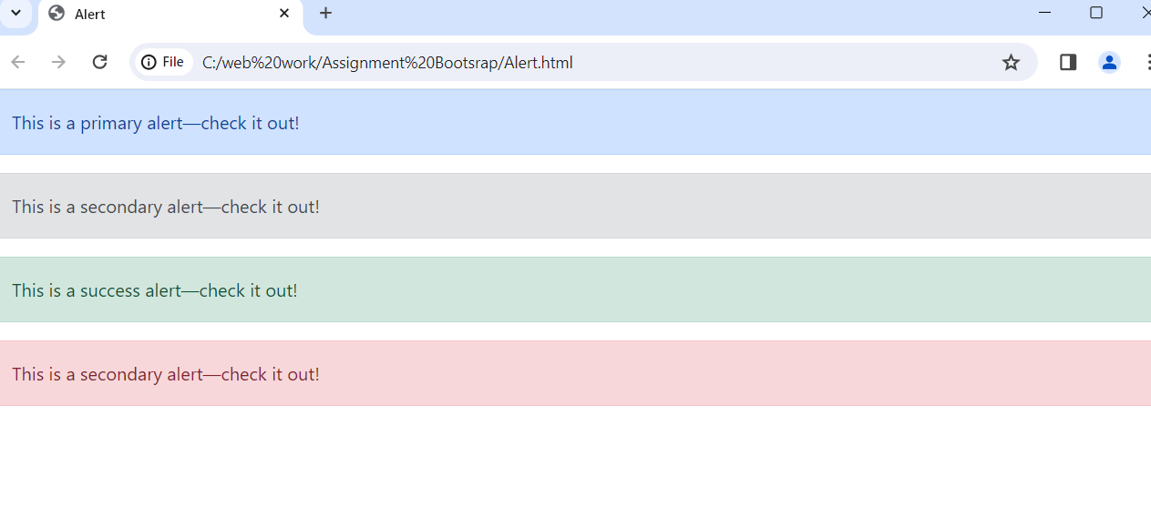

**9. What is a bootstrap card and how would you create one?**

**Ans:-**

Bootstrap’s cards provide a flexible and extensible content container with multiple variants and options.

**Ex:-**

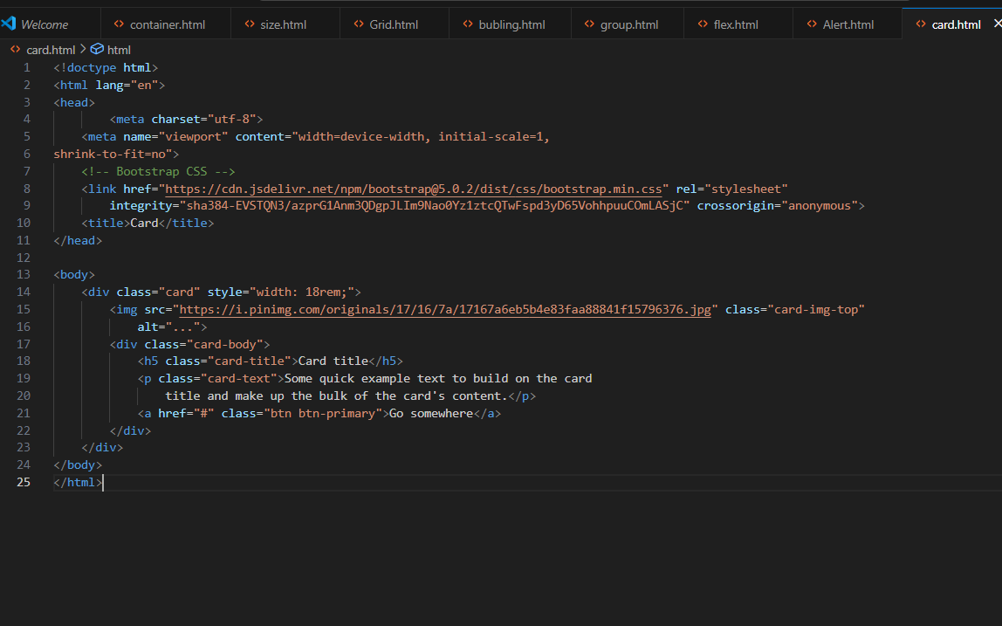

**Output:-**

